Centennial Farm & Ranch
Historic Structures Award

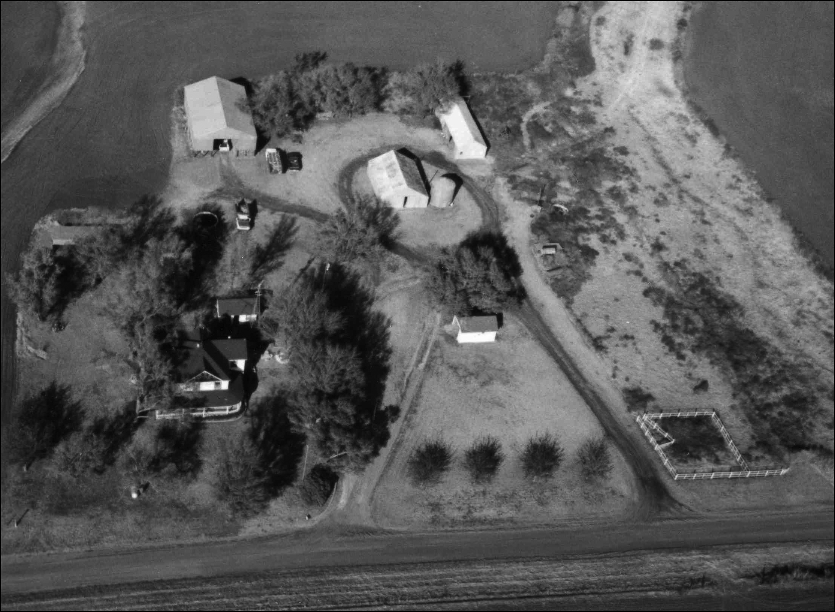

Forms
&
Instructions

Mail Completed Forms to:

State Historic Preservation Office
Oklahoma Historical Society
Oklahoma History Center
800 Nazih Zuhdi Drive
Oklahoma City, OK 73105-7917
January 2018
<This page left intentionally blank>

Dear Historic Structures Award Applicant:

Thank you for your interest in applying for the Oklahoma Centennial Farm and Ranch Program's Historic Structures Award. If your property qualifies as either an Oklahoma Centennial Farm or Ranch, you may also be eligible for this additional recognition.

There must be at least four (4) buildings and/or structures (such as a windmill, cellar, etc.) located on your farm or ranch that are each at least fifty (50) years old and that have not been significantly modified (that is, they must retain their overall historic character or integrity). We will use the included National Register of Historic Places criteria for the evaluation of each resource's historic integrity.

Enclosed you will find the necessary forms (Historic Preservation Resource Identification Form) required to apply for this award and instructions for completing them. Along with the forms, please include photographs of each building or structure and a site plan that shows their locations and relationship to one another. Please label the photographs according to the sample found in this packet.

If you have any questions or concerns, please contact me at 405/522-4485 or sjotley@okhistory.org.

Sincerely,

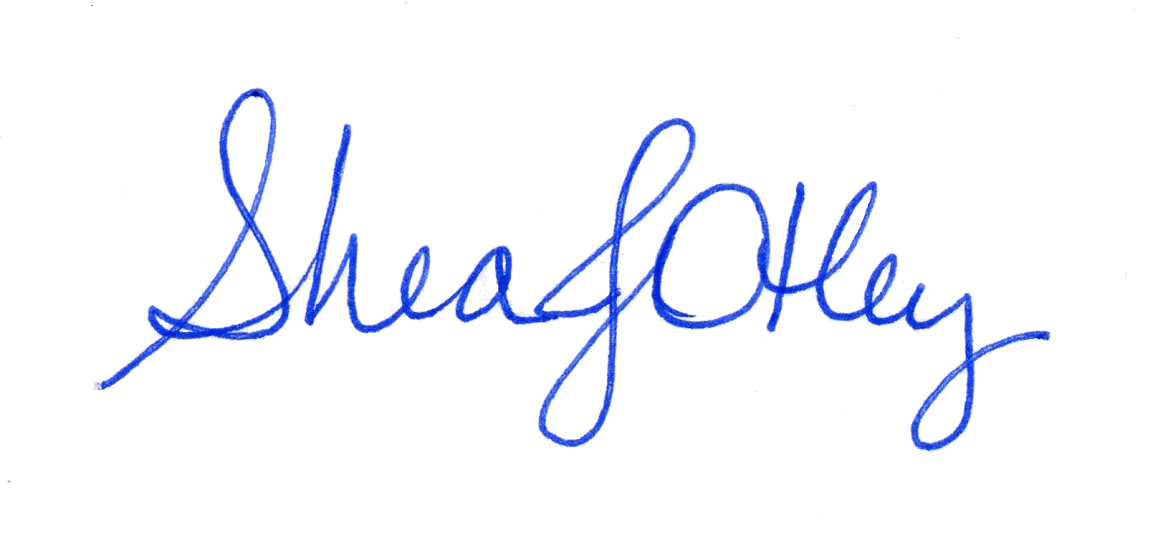

Shea J. Otley
Oklahoma Centennial
Farm & Ranch Program Coordinator
<This page left intentionally blank>
CRITERIA FOR EVALUATION

The following criteria are designed to guide States, Federal agencies, and the Secretary of the Interior in evaluating entries for the National Register.

The quality of significance in American history, architecture, archaeology, and culture is present in districts, sites, buildings, structures, and objects that possess integrity of location, design, setting, material, workmanship, feeling, and association, and:

- that are associated with events that have made a significant contribution to our broad patterns of our history; or
- that are associated with the lives of persons significant in our past; or
- that embody the distinctive characteristics of a type, period, or method of construction, or that represent a significant and distinguishable entity whose components may lack individual distinction; or
- that have yielded or may be likely to yield information important to prehistory or history.

Ordinarily, cemeteries, birthplaces, or graves of historical figures, properties owned by religious institutions or used for religious purposes, structures that have been moved from their original locations, reconstructed historic buildings, properties primarily commemorative in nature, and properties that have achieved significance within the last 50 years shall not be considered for the National Register. Such properties will qualify if they are integral parts of districts that meet the criteria or if they fall within the following categories:

- a religious property deriving primary significance from architectural or artistic distinction or historical importance; or
- a building or structure removed from its original location but which is significant primarily for architectural value, or which is the surviving structure most importantly associated with a historic person or event; or
- a birthplace or grave of a historical figure of outstanding importance if there is no other appropriate site or building directly associated with his productive life; or
- a cemetery that derives its primary significance from graves of person of transcendent importance, from age, from distinctive design features, or from association with historic events; or
- a reconstructed building when accurately executed in a suitable environment and presented in a dignified manner as a part of a restoration master plan, and when no other building or structure with the same association has survived; or
- a property primarily commemorative in intent if design, age, tradition, or symbolic value has invested it with its own historical significance; or
- a property achieving significance within the past 50 years if it is of exceptional importance.
<This page left intentionally blank>
INSTRUCTIONS
Historic Structures Forms

TYPE ALL ENTRIES

- PROPERTY NAME. List the name of your property. (Example: Lollypop Ranch, Mayes Farm, William Homestead, etc.)

- RESOURCE NAME. List the type of building or structure for which you are completing this form. (Example: barn, chicken coop, shed, windmill, etc.) Resource name listed on this form should match how the building or structure was listed on the farm and ranch application.

- ADDRESS. List the address of your property or directions from the nearest major intersection.

- CITY. What is the nearest city or town (with a U.S. Post Office)?

- VICINITY. If the building or structure is located within the city limits, leave blank. If it is not located within the city limits, put a “V”.

- COUNTY NAME. In what county is the building or structure located?

- LOT. The lots on which the building or structure is located. (For most rural properties, this does not apply.)

- BLOCK. The block on which the building or structure is located. (For most rural properties, this does not apply.)

- PLAT NAME. The legally recorded name of the subdivision that is listed in the official plat book. (For most rural properties, this does not apply.)

- SECTION. Section number and nearest 1/4 division. (Example: NE 1/4 of SW 1/4 of Section 25)

- TOWNSHIP. Township number. (Example: Township 15 North or T15N)

- RANGE. Range number. (Example: Range 8 East or R8E)

- LATITUDE (NORTH): Leave blank

- LONGITUDE (WEST): Leave blank

- UTM ZONE: Leave blank

- NORTHINGS: Leave blank

- EASTINGS: Leave blank

- RESOURCE TYPE. Choose from the following:
Building
Site
Object
Structure

- HISTORIC FUNCTION. For what purpose was the building or structure used? (Example: shed, storage, etc.)

- CURRENT FUNCTION. For what purpose is the building currently used, if any?

- AREA OF SIGNIFICANCE, PRIMARY. See list following instructions. For most farm and ranch properties, the primary area of significance will be agriculture.

- AREA OF SIGNIFICANCE, SECONDARY. See list following instructions.

- DESCRIPTION OF SIGNIFICANCE. Why is your property important? Please explain. (Example: Property is the longest continually operating ranch in the county.)

- DOCUMENTATION SOURCES. Where did you find your information about the property? (Examples: county history, interviews, family history, county records, etc.)

- NAME OF PREPARER. Who prepared this form?

59. SURVEY PROJECT. Leave blank.

- PROJECT NAME. Leave blank

- DATE OF PREPARATION. On what date was the form completed?

- PHOTOGRAPHS. Are you including photographs?
- YEAR. When were they taken?

- ARCHITECT/BUILDING. Who constructed the buildings or structures?

- YEAR BUILT. Approximately when was the building or structure constructed. (Example: circa 1902)

- ORIGINAL SITE. Has the building or structure been moved?
- DATE MOVED. When was it moved?
- FROM WHERE. What was the original location?

- ACCESSIBLE. Is the building or structure viewable from a public road?

- ARCHITECTURAL STYLE. See list following instructions. If none apply, choose no style.

- OTHER ARCHITECTURAL STYLE. See list following instructions.

- FOUNDATION MATERIAL. What is the primary material in the foundation? See list following instructions.

- ROOF TYPE. What is the primary type of roof on the building or structure? See list following instructions.

- ROOF MATERIAL. What is the primary roofing material? See list following instructions.

- WALL MATERIAL, PRIMARY. What material covers the exterior walls of the building or structure? (Example: brick, stone, wood – See list following instructions.)

- WALL MATERIAL, SECONDARY. Use this space to list any additional exterior wall materials. See list following instructions.

- WINDOW TYPE. The types below are the most common (see included images for additional window types and illustrations):
Hung - One or both panes can be moved up and down to provide ventilation.
Fixed – The window does not open.

- WINDOW MATERIAL. The most common types are wood, metal, and vinyl. If the window has storm windows, describe the actual window and not the storm windows.

- DOOR TYPE. The most common types are (see attached for illustrations):
Paneled – Solid door divided into panels.
Slab – Solid door.
Glazed Panel – Door with multiple divided glass panes.
Glazed Slab – Metal or wood-framed door with a single large pane of glass.

- DOOR MATERIAL. The most common types are wood and metal. (see attached for additional materials.)

- EXTERIOR FEATURES. Describe any outstanding exterior structural elements of the building or structure. (Example: porches, chimneys, dormers, etc.)

- INTERIOR FEATURES. Describe any outstanding interior elements of the building or structure. (Example: mantles, staircases, decorative woodwork, stalls, lofts, etc.)

- DECORATIVE DETAILS. Describe any special or unique decorations and trims that were historically on the building or structure and that are still present.

- CONDITION OF RESOURCE. Excellent = perfectly maintained; Good = very well maintained; Fair = somewhat in need of maintenance; Poor = badly in need of maintenance; Ruins = most or all of the building or structure is destroyed or missing.

- DESCRIPTION OF RESOURCE (Present and Historic). Describe the building or structure’s appearance, making note of any known alterations that have occurred since original construction. (See sample form for example)

- COMMENTS. Use this space to provide any additional information.

- ATTACH LOCATION MAP. Provide a sketch map showing this building or structure’s location in relation to the rest of the property. (See sample form for example)

- LISTED ON NATIONAL REGISTER. Is property listed on the National Register.

- NATIONAL REGISTER ENTRY. Leave blank.

- CONTINUATION. If you have additional information to add, include it here.
COUNTY LIST

ADAIR | AD | LEFLORE | LF
ALFALFA | AL | LINCOLN | LN
ATOKA | AT | LOGAN | LG
BEAVER | BV | LOVE | LV
BECKHAM | BK | McCLAIN | ML
BLAINE | BL | McCURTAIN | MC
BRYAN | BR | McINTOSH | MI
CADDO | CD | MAJOR | MJ
CANADIAN | CN | MARSHALL | MA
CARTER | CA | MAYES | MY
CHEROKEE | CK | MURRAY | MR
CHOCTAW | CH | MUSKOGEE | MS
CIMARRON | CI | NOBLE | NB
CLEVELAND | CL | NOWATA | NW
COAL | CO | OKFUSKEE | OF
COMANCHE | CM | OKLAHOMA | OK
COTTON | CT | OKMULGEE | OG
CRAIG | CG | OSAGE | OS
CREEK | CR | OTTAWA | OT
CUSTER | CU | PAWNEE | PW
DELAWARE | DL | PAYNE | PY
DEWEY | DW | PITTSBURG | PS
ELLIS | EL | PONTOTOC | PN
GARFIELD | GF | POTTAWATOMIE | PT
GARVIN | GV | PUSHMATAHA | PU
GRADY | GD | ROGER MILLS | RM
GRANT | GT | ROGERS | RO
GREER | GR | SEMINOLE | SM
HARMON | HR | SEQUOYAH | SQ
HARPER | HP | STEPHENS | ST
HASKELL | HS | TEXAS | TX
HUGHES | HU | TILLMAN | TI
JACKSON | JK | TULSA | TU
JEFFERSON | JF | WAGONER | WG
JOHNSTON | JN | WASHINGTON | WN
KAY | KA | WASHITA | WA
KINGFISHER | KG | WOODS | WO
KIOWA | KI | WOODWARD | WD
LATIMER | LT
Historic Preservation Resource Identification Terms

RESOURCE TYPES

DISTRICT
BUILDING
SITE
OBJECT
STRUCTURE

FUNCTION TYPES

DOMESTIC | POST OFFICE
SINGLE DWELLING | PUBLIC WORKS
MULTIPLE DWELLING | COURTHOUSE
SECONDARY STRUCTURE | EDUCATION
HOTEL | SCHOOL
INSTITUTIONAL HOUSING | COLLEGE
CAMP | LIBRARY
VILLAGE SITE | RESEARCH FACILITY
COMMERCE/TRADE | EDUCATIONAL-RELATED HOUSING
BUSINESS | RELIGION
PROFESSIONAL | RELIGIOUS STRUCTURE
ORGANIZATIONAL | CEREMONIAL SITE
FINANCIAL INSTITUTION | CHURCH SCHOOL
SPECIALTY STORE | CHURCH-RELATED RESIDENCE
DEPARTMENT STORE | FUNERARY
RESTAURANT | CEMETERY
WAREHOUSE | GRAVES/BURIALS
TRADE (ARCHEOLOGY) | MORTUARY
SOCIAL | RECREATION
MEETING HALL | THEATER
CLUBHOUSE | AUDITORIUM
CIVIC | MUSEUM
GOVERNMENT | MUSIC FACILITY
CAPITOL | SPORT FACILITY
CITY HALL | OUTDOOR RECREATION
CORRECTIONAL FACILITY | FAIR
FIRE STATION | MONUMENT/MARKER
GOVERNMENT OFFICE | WORK OF ART (SCULPTURE, CARVING, ROCK ART)
DIPLOMATIC BUILDING
CUSTOM HOUSE
FUNCTION TYPES (CONTINUED)

AGRICULTURE/SUBSISTENCE | CONSERVATION AREA
PROCESSING | STREET FURNITURE/STRUCTURE
STORAGE | CONSERVATION
AGRICULTURAL FIELD | TRANSPORTATION
ANIMAL FACILITY | RAIL-RELATED
FISHING FACILITY OR SITE | AIR-RELATED
AGRICULTURAL OUTBUILDINGS | WATER-RELATED
HORTICULTURE FACILITY | ROAD-RELATED
IRRIGATION FACILITY | PEDESTRIAN-RELATED
INDUSTRY/PROCESSING EXTRACTION | WORK IN PROGRESS
MANUFACTURING FACILITY | UNKNOWN
EXTRACTIVE FACILITY | VACANT/NOT IN USE
WATER WORKS | OTHER
ENERGY FACILITY
COMMUNICATION FACILITY
PROCESSING SITE
HEALTH CARE
HOSPITAL
CLINIC
SANITORIUM
MEDICAL BUSINESS/OFFICE
RESORT
DEFENSE
ARMS STORAGE
FORTIFICATION
MILITARY FACILITY
BATTLE SITE
COAST GUARD FACILITY
NAVAL FACILITY
AIR FACILITY
LANDSCAPE
PARKING LOT
PARK
PLAZA
GARDEN
FOREST
UNOCCUPIED LAND
UNDERWATER
NATURAL FEATURE
STREET FURNITURE/OBJECT
AREA OF SIGNIFICANCE

AGRICULTURE
ARCHEOLOGY
PREHISTORIC ARCHEOLOGY
HISTORIC – ABORIGINAL
HISTORIC – NON-ABORIGINAL
ARCHITECTURE
ART
COMMERCE
COMMUNICATIONS
COMMUNITY PLANNING AND DEVELOPMENT
CONSERVATION
ECONOMICS
EDUCATION
ENGINEERING
ENTERTAINMENT/RECREATION
ETHNIC HERITAGE
ASIAN
BLACK
EUROPEAN
HISPANIC
NATIVE AMERICAN
OTHER
EXPLORATION/SETTLEMENT
HEALTH/MEDICINE
INDUSTRY
INVENTION
LANDSCAPE ARCHITECTURE
LAW
LITERATURE
MARITIME HISTORY
MILITARY
PERFORMING ARTS
PHILOSOPHY
POLITICS/GOVERNMENT
RELIGION
SCIENCE
SOCIAL HISTORY
TRANSPORTATION
OTHER
ARCHITECTURAL STYLE

NO DISTINCTIVE STYLE | NATIONAL FOLK
COLONIAL | SHOTGUN
EARLY REPUBLIC | FOLK VICTORIAN
FEDERAL | MIXED (More Than Two Styles From Different Periods)
MID 19TH CENTURY | OTHER (PROVIDE NAME OF STYLE BELOW)
GREEK REVIVAL | MINIMAL TRADITIONAL
GOTHIC REVIVAL | RANCH
ITALIAN REVIVAL | SPLIT-LEVEL
EXOTIC REVIVAL | CONTEMPORARY
OCTAGON MODE | SHED
LATE VICTORIAN | ORGANIC
GOTHIC | A-FRAME
ITALIANATE | NEW FORMALISM
SECOND EMPIRE | BRUTALISM
STICK/EASTLAKE | POST MODERN
QUEEN ANNE | MANSARD
SHINGLE STYLE | STYLIZED RANCH
ROMANESQUE | NEO-COLONIAL
RENAISSANCE
LATE 19TH AND EARLY 20TH CENTURY
REVIVALS
COLONIAL REVIVAL
CLASSICAL REVIVAL
TUDOR REVIVAL
LATE GOTHIC REVIVAL
MISSION/SPANISH COLONIAL REVIVAL
BEAUX ARTS
PUEBLO
SECOND RENAISSANCE REVIVAL
LATE 19TH AND EARLY 20TH CENTURY
AMERICAN MOVEMENTS
PRAIRIE SCHOOL
COMMERCIAL STYLE
CHICAGO
SKYSCRAPER
BUNGALOW/CRAFTSMAN
MODERN MOVEMENT
MODERNE
INTERNATIONAL STYLE
ART DECO
MATERIAL TYPES

NONE LISTED | STEEL
EARTH | LEAD
WOOD | NICKEL
WEATHERBOARD | CAST IRON
SHINGLE | STUCCO
LOG | TERRA COTTA
PLYWOOD/PARTICLE BOARD | ASPHALT
SHAKE | ASBESTOS
BRICK | CONCRETE
STONE | ADOBE
GRANITE | CERAMIC TILE
SANDSTONE | GLASS
LIMESTONE | CLOTH/CANVAS
MARBLE | SYNTHETICS
SLATE | FIBERGLASS
METAL | VINYL
IRON | RUBBER
COPPER | PLASTIC
BRONZE | OTHER
TIN | INAPPLICABLE
ALUMINUM | UNCOLLECTED
CONDITION
EXCELLENT (PERFECTLY MAINTAINED)
GOOD (VERY WELL MAINTAINED)
FAIR (SOMEWHAT IN NEED OF MAINTENANCE)
POOR (BADLY IN NEED OF MAINTENANCE)
RUINS (MOST OR ALL OF RESOURCE IS DESTROYED OR MISSING)

COMMON ARCHITECTURAL STYLES

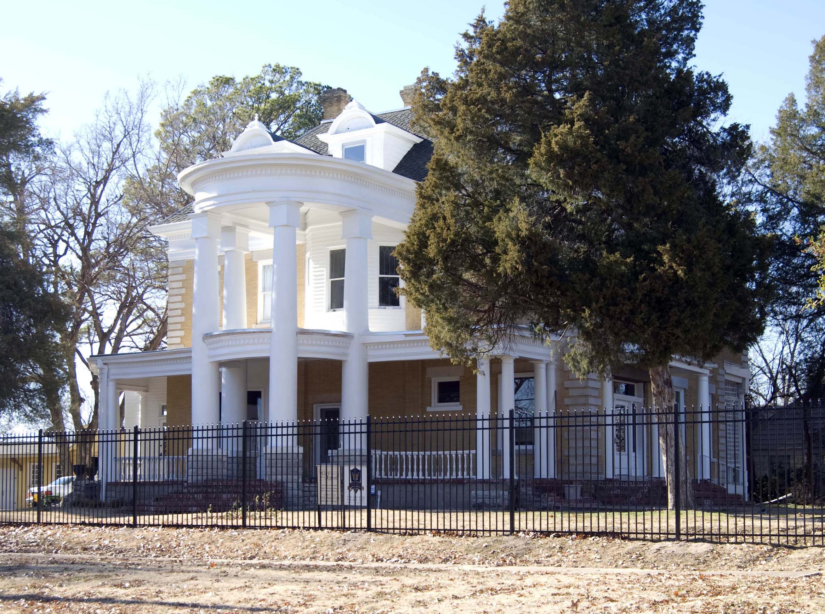 | 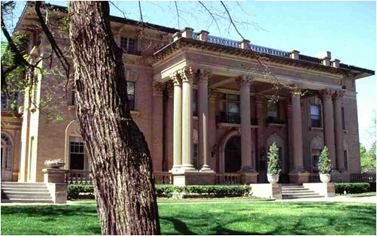
Features of the Classical Revival Style
- Full height porch
- Classical columns with Ionic or Corinthian capitals
- Façades with symmetrically balanced windows and central door

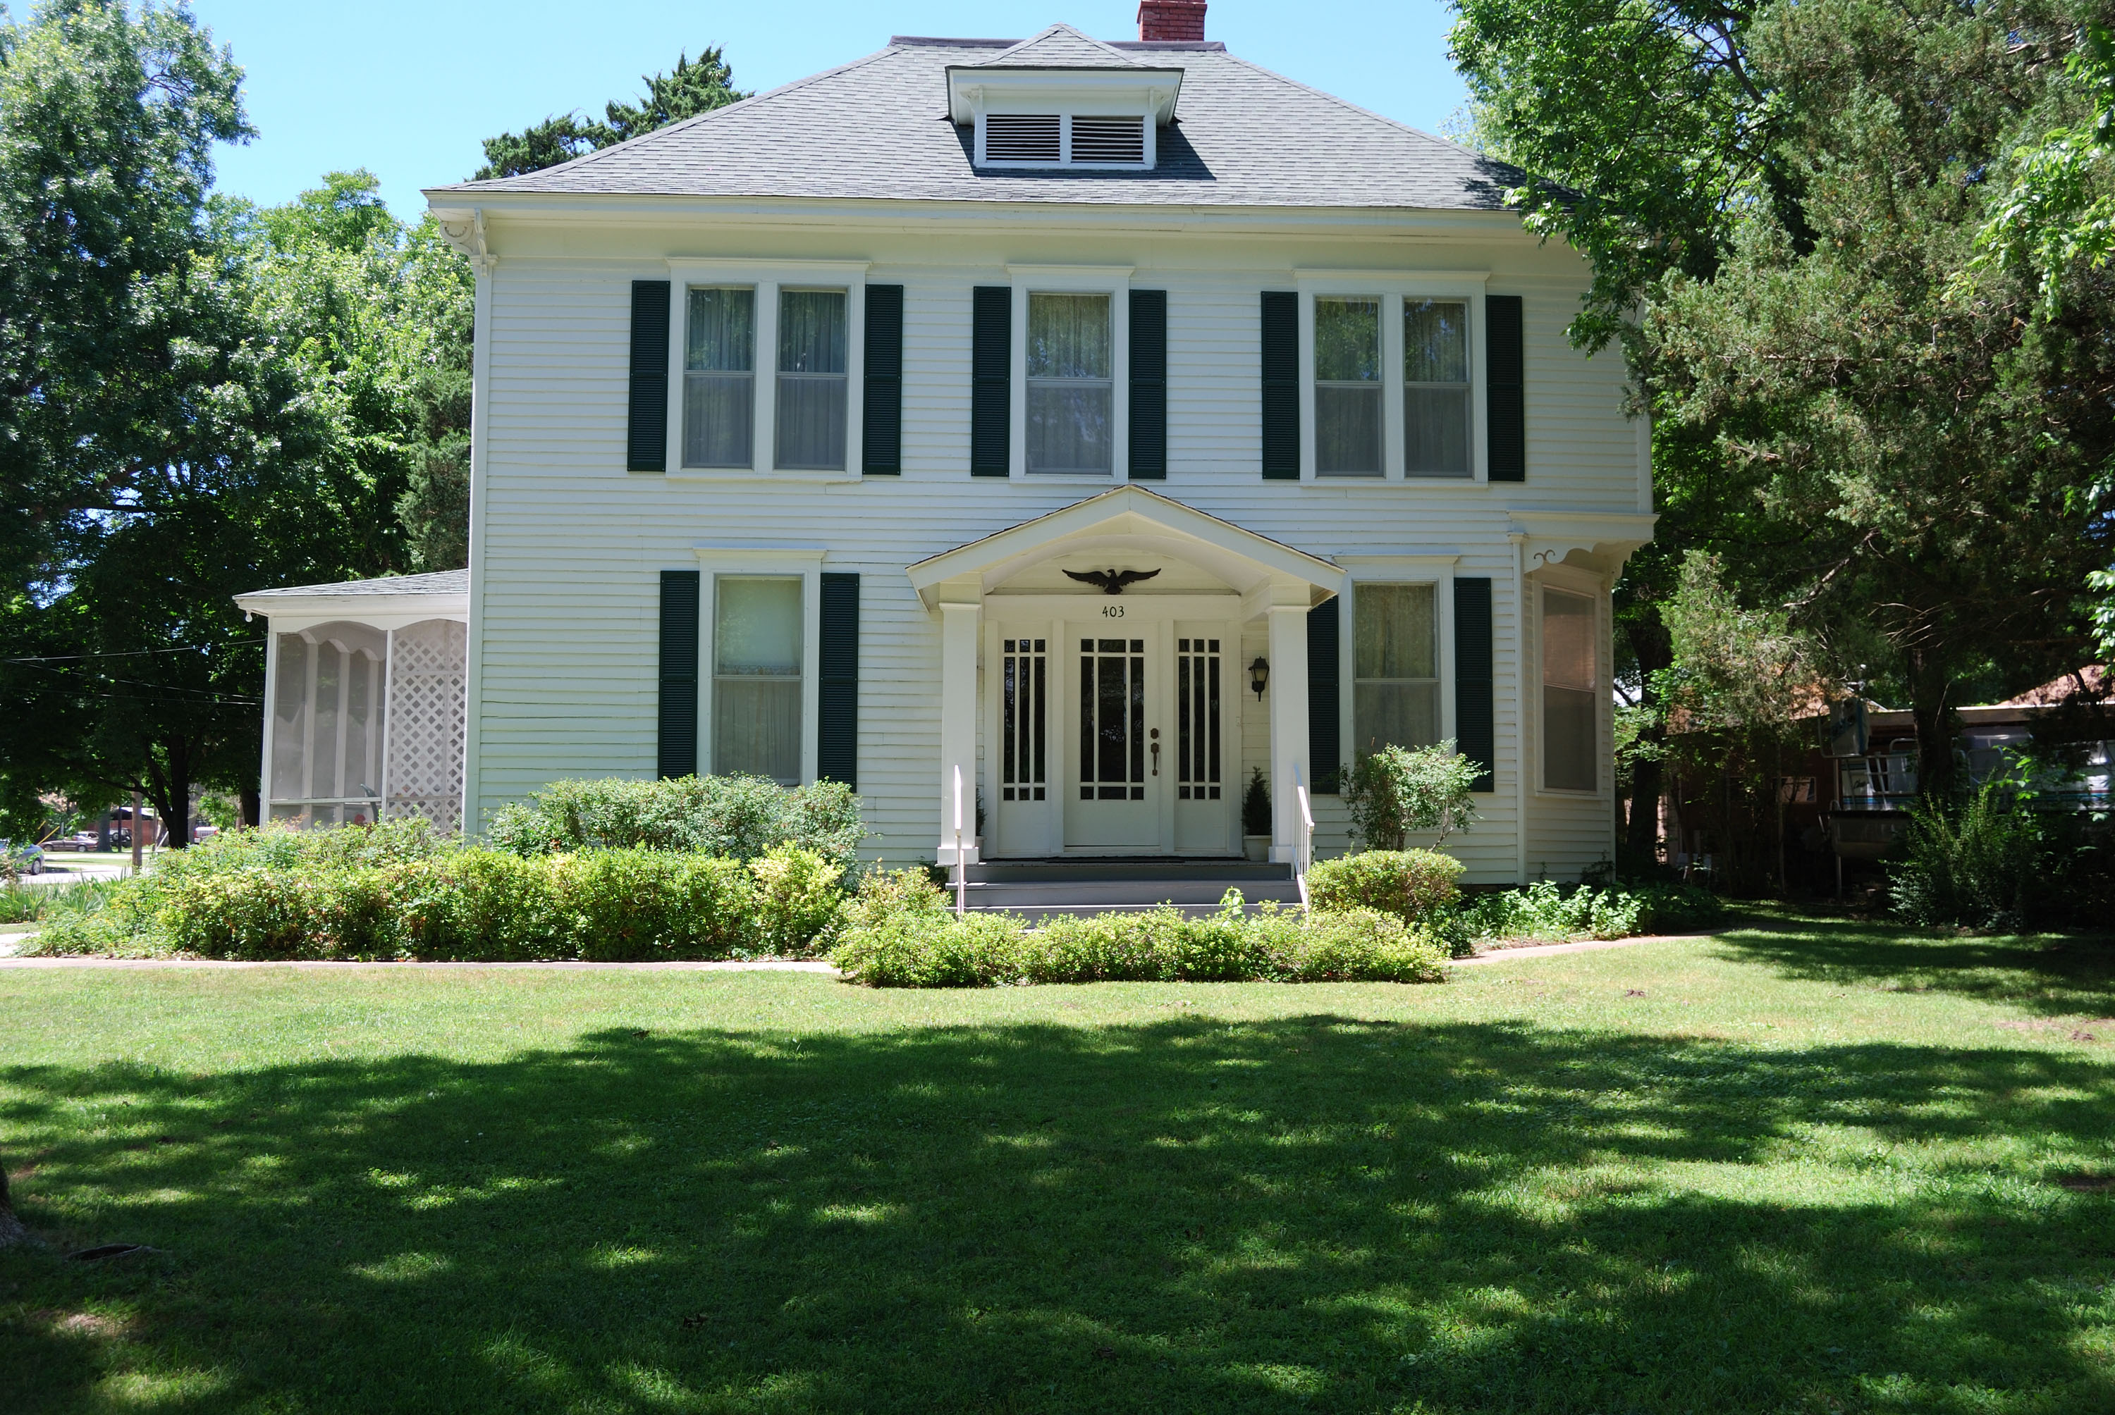 | 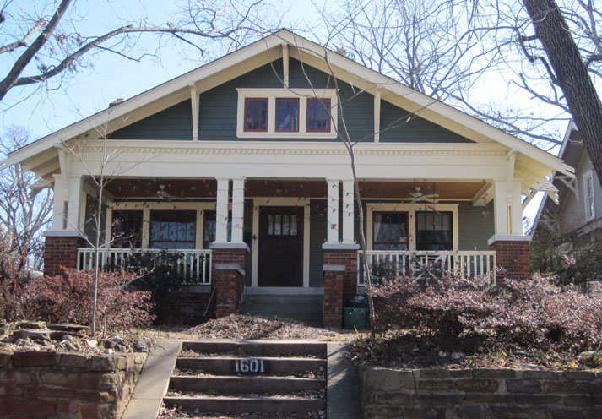
Features of the Colonial Revival Style  - Accentuated front door with decorative pediment  - Pilasters/columns supporting entry porch  - Entry doors with fanlights or sidelights  - Symmetrically balanced windows with central door  - Adjacent double hung windows with multi-pane glazing | Features of the Craftsman Style  - Low-pitched, gabled roof  - Exposed roof rafters  - Full- or partial-width porches with tapered columns or piers  - Commonly one or one and one-half stories high

COMMON ARCHITECTURAL STYLES
(Continued)
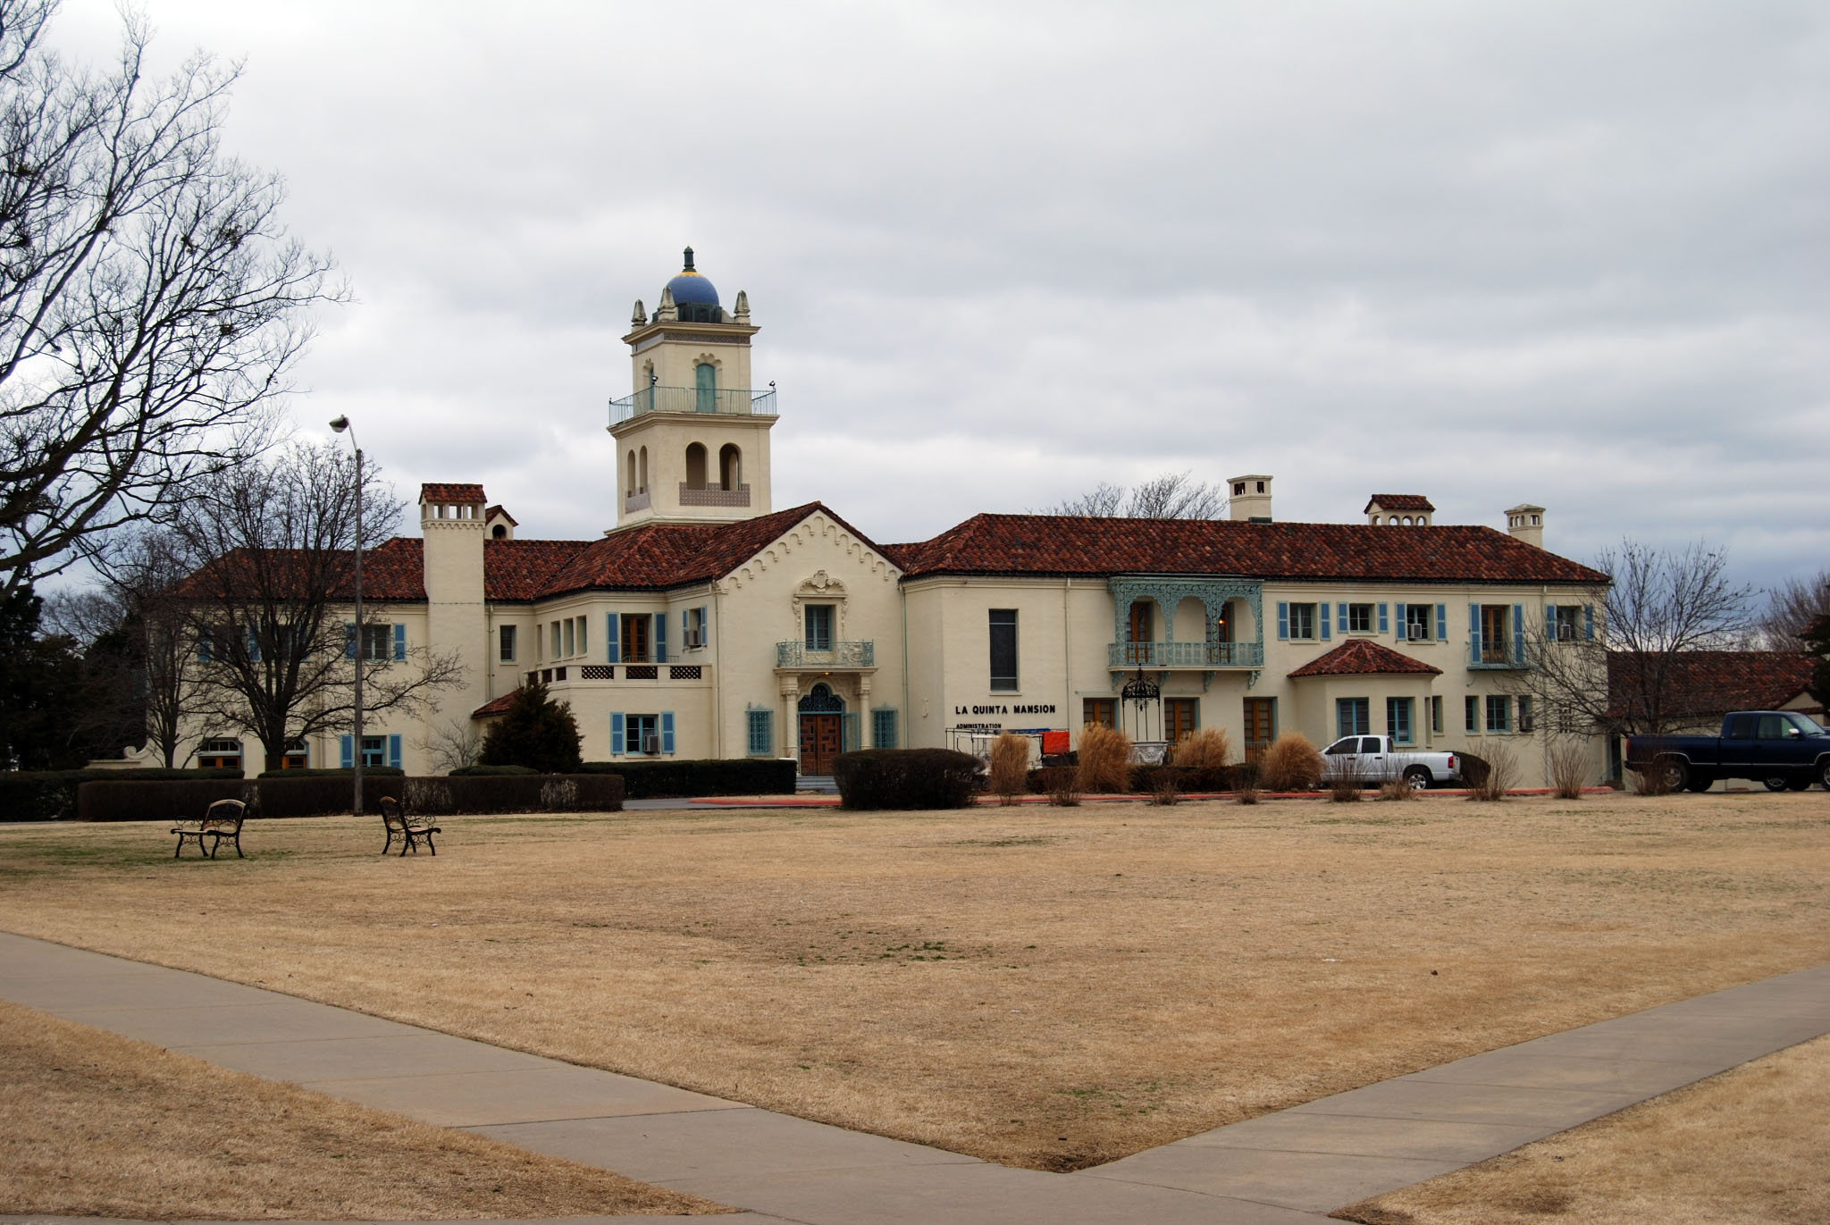 | 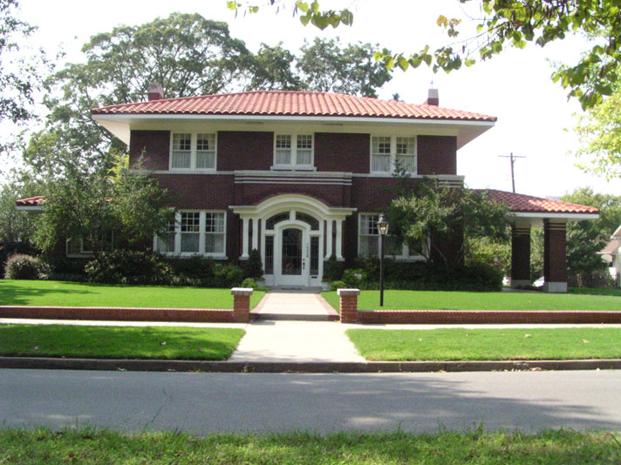
Features of the Mission Spanish  Colonial Revival Style  - Mission-shaped dormer or roof parapet  - Red tile roof covering  - Wall surfaces typically stucco  - Façade typically asymmetrical  - Prominent arches placed on porch, door and/or windows | Features of the Prairie School Style  - Low-pitched roof, usually hipped  - Two stories with one-story wing porches and porte cocheres  - Details emphasize the horizontal lines  - Massive, square porch supports
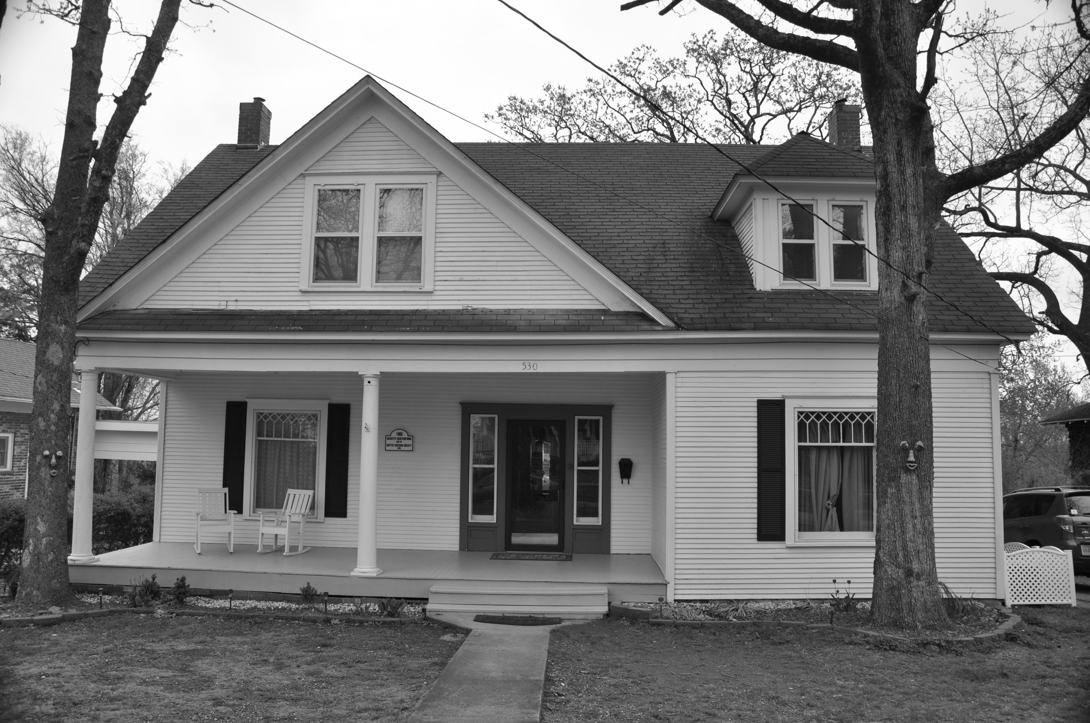 |  | 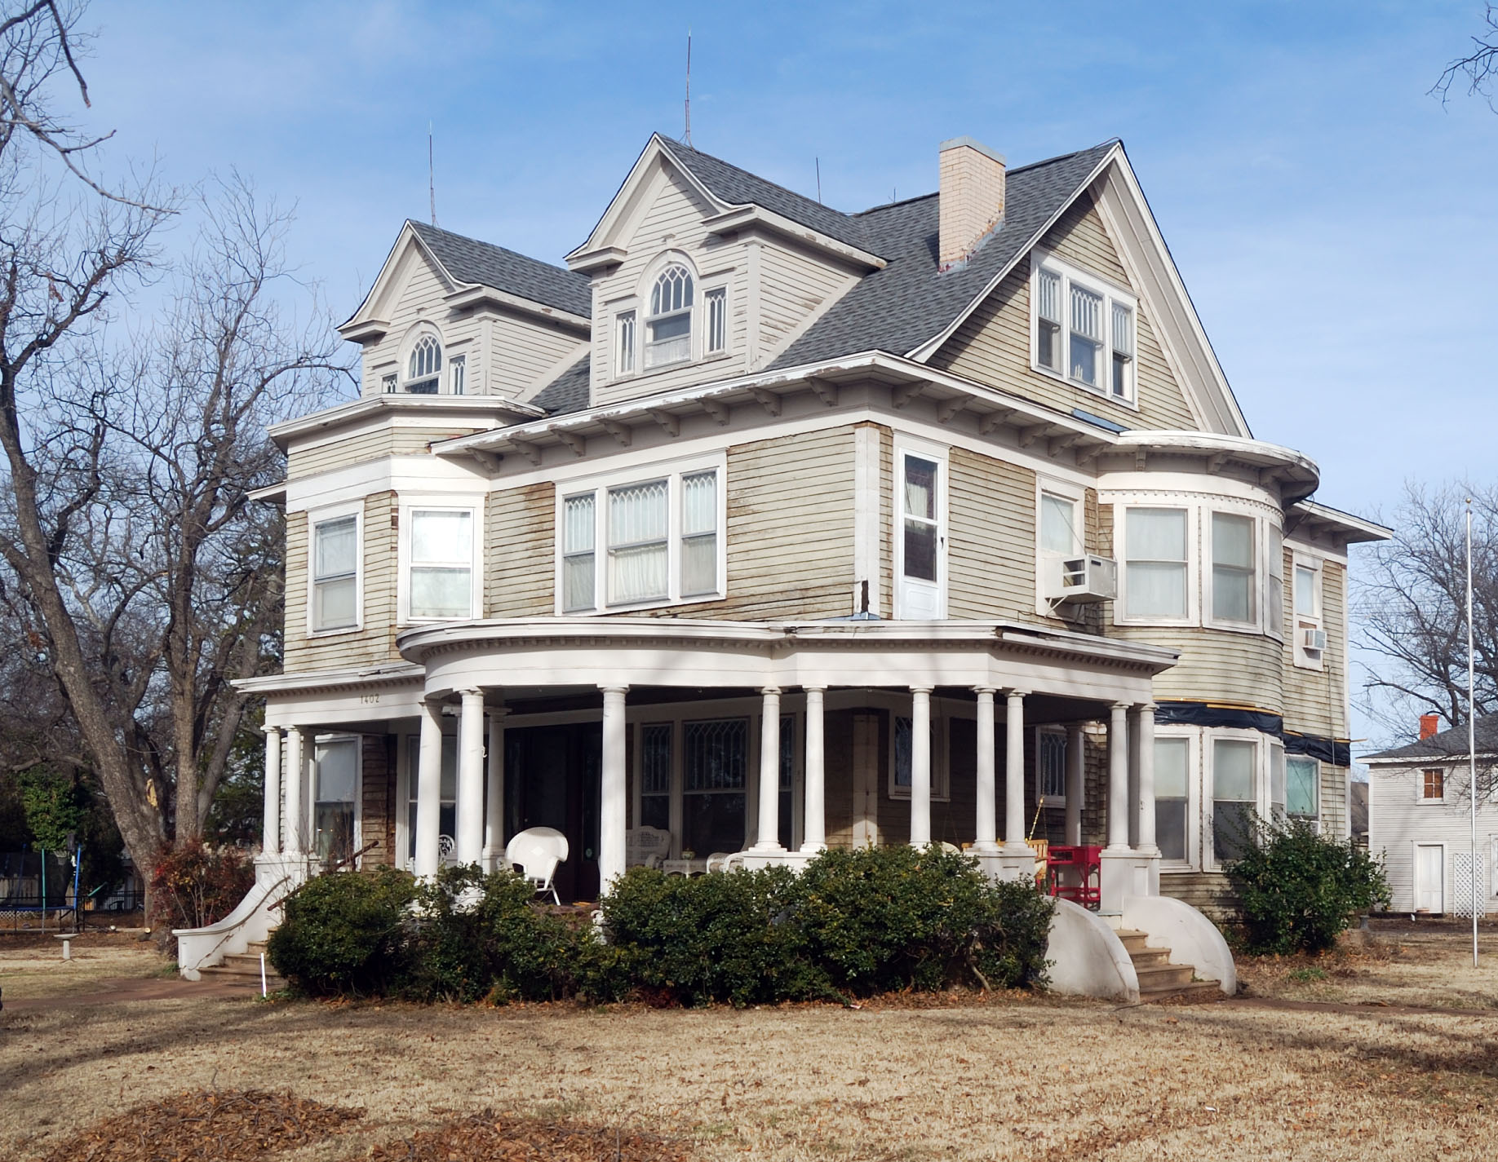
Features of the Queen Anne Style
- Steeply pitched roof of irregular shape
- Patterned shingles, cutaway bay windows and other devices used to avoid a smooth-walled appearance
- Asymmetrical façade with a partial- or full-width porch which is usually one story high and extends along one or both side walls.
COMMON ARCHITECTURAL STYLES
(Continued)

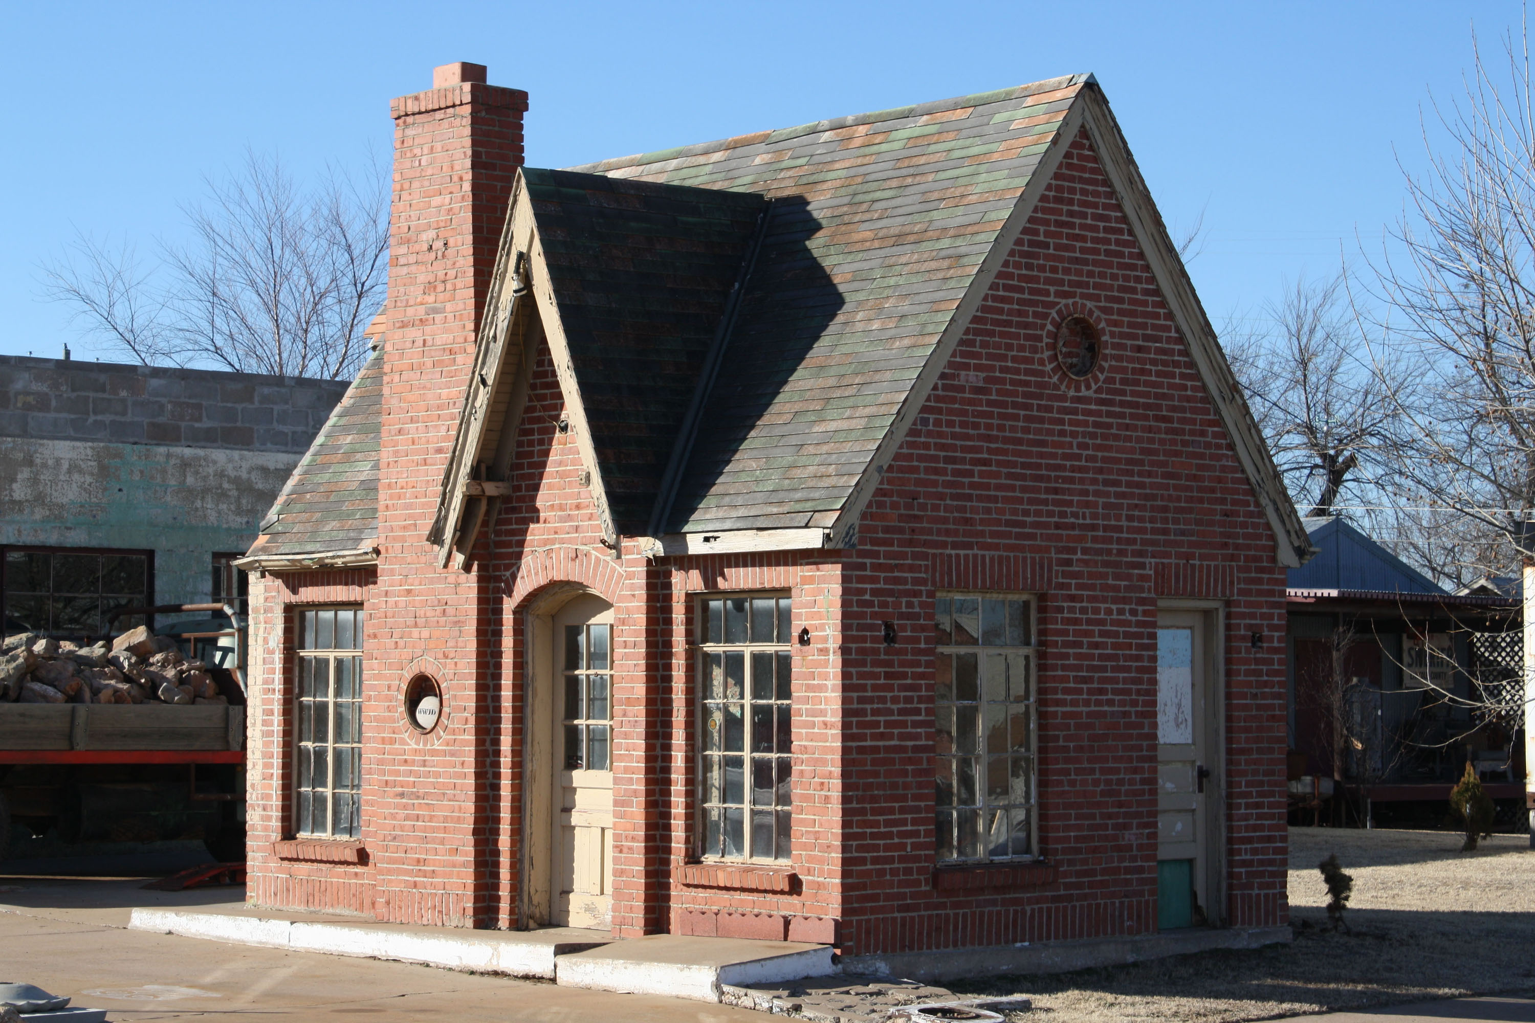 | 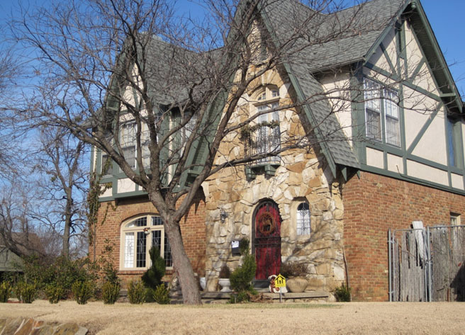
Features of the Tudor Style
- Steeply pitched roof, usually side-gabled
- Façade is dominated by one or more front-facing gables
- Tall, narrow, multi-pane windows
- Massive chimneys
- Decorative half-timbering present on roughly one-third of examples

ROOF TYPES

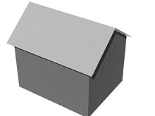 | 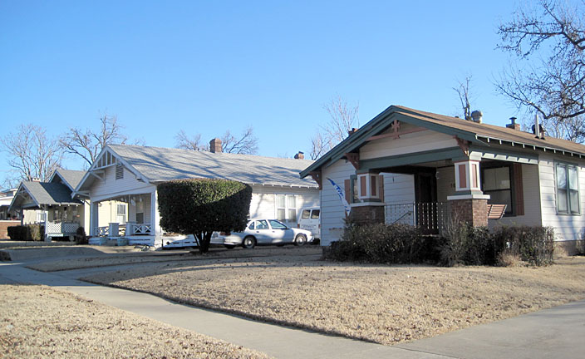
FRONT GABLE
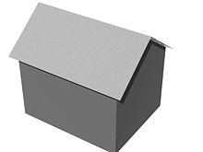 | 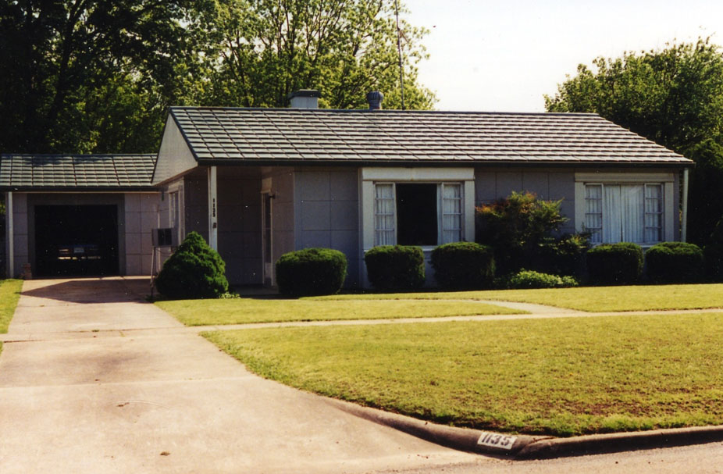
SIDE GABLE
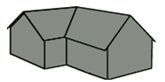 | 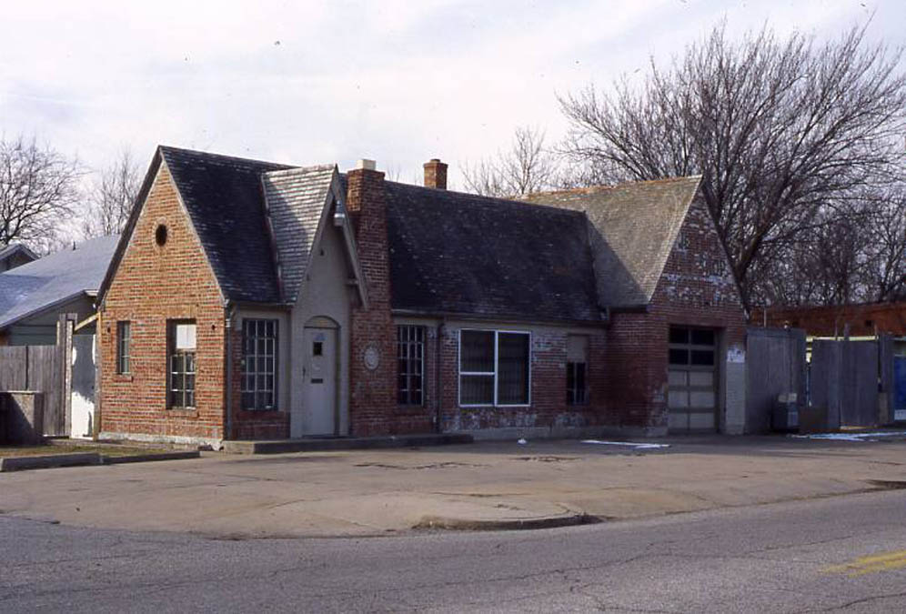
CROSS GABLE

ROOF TYPES
(Continued)

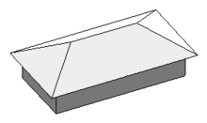 | 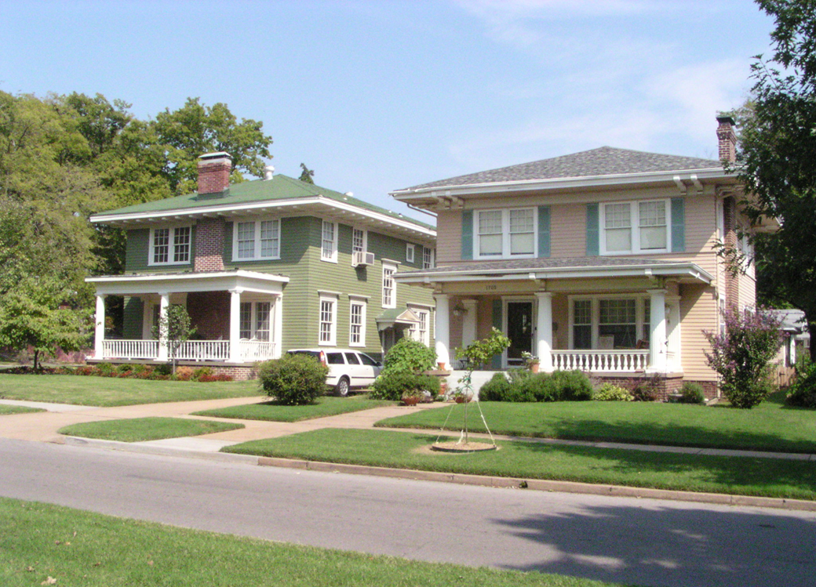
HIPPED
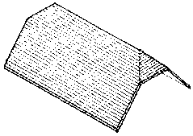 | 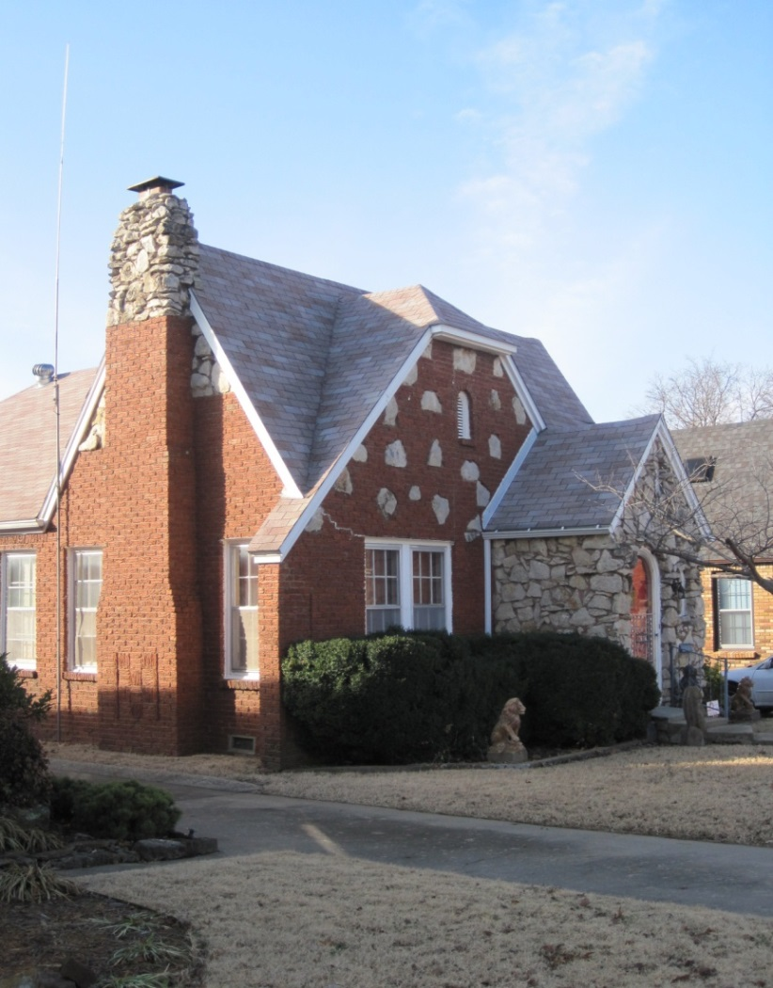
HIPPED GABLE

ROOF TYPES
(Continued)

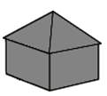 | 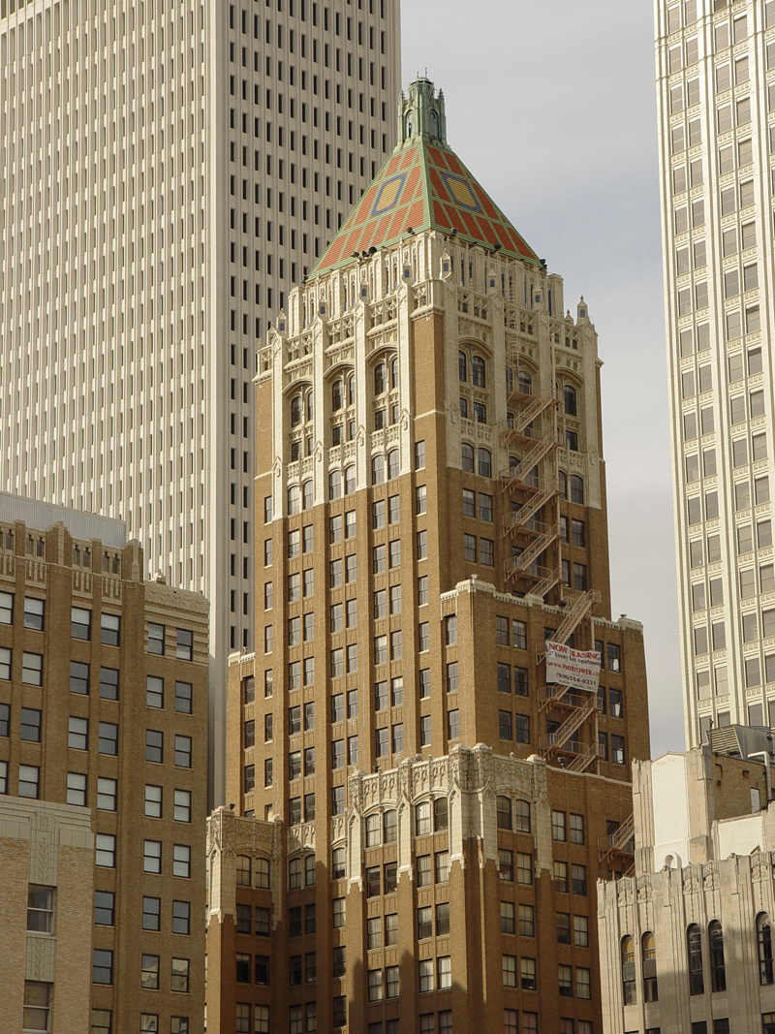
PYRAMID
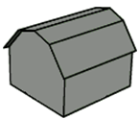 | 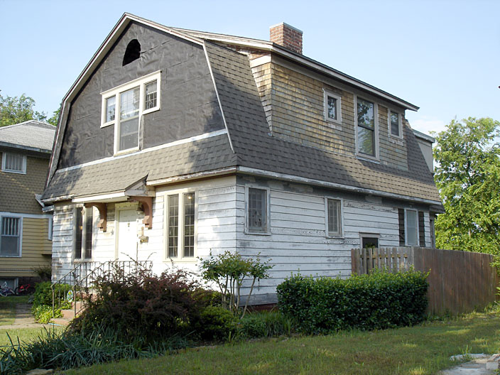
GAMBREL
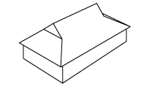 | 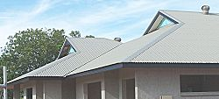
HIP WITH GABLET

ROOF TYPES
(Continued)

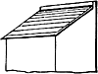 | 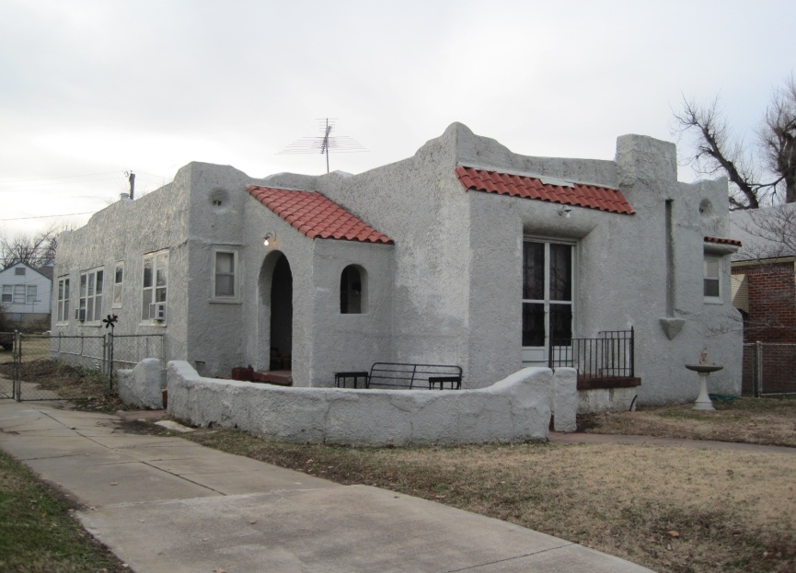
SHED
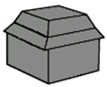 | 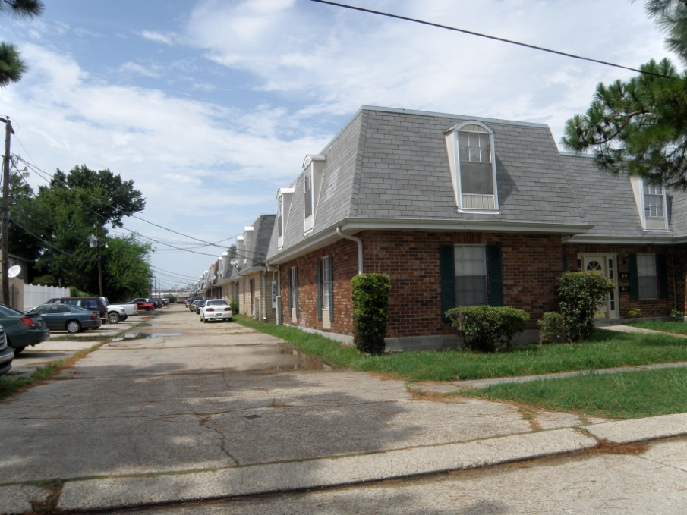
MANSARD
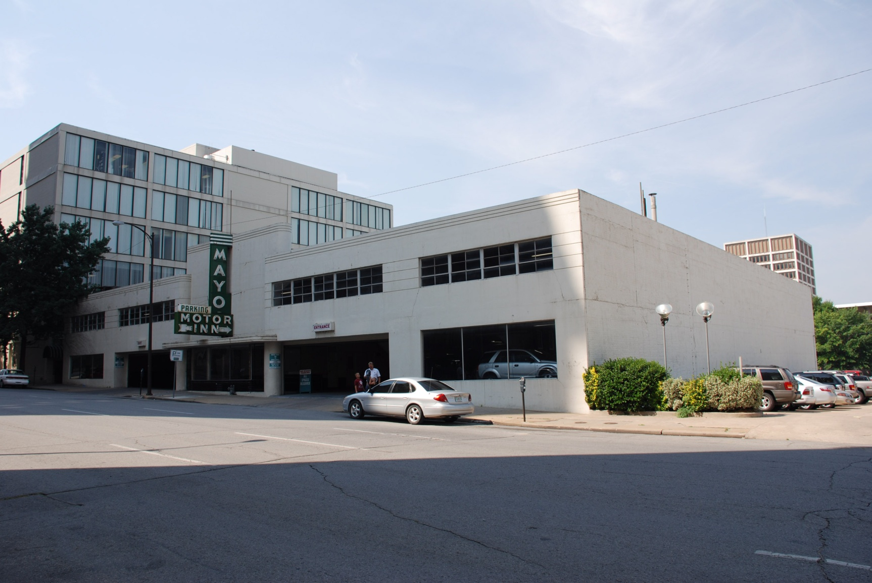
FLAT

WINDOW TYPES

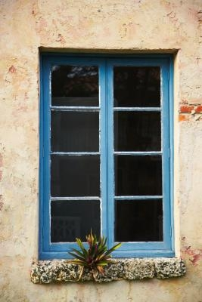 | 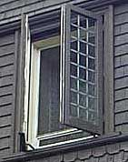 | 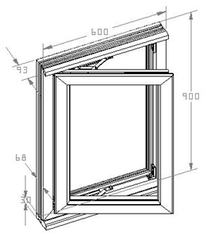
CASEMENT
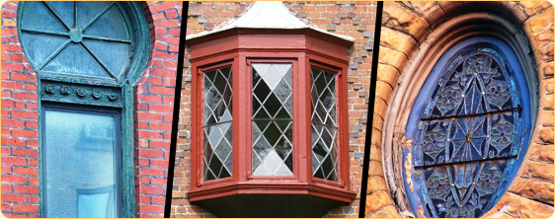
 | FIXED

WINDOW TYPES
(Continued)

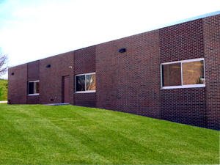 |  | 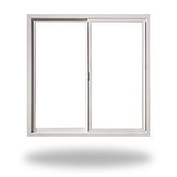
SLIDE
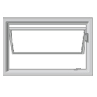 |  |  | 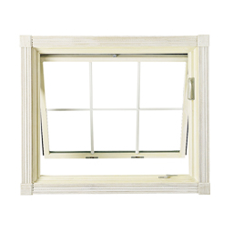
 | AWNING

WINDOW TYPES
(Continued)

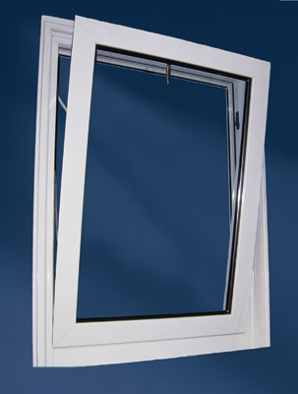 |  | 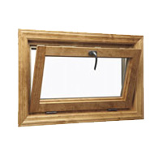
HOPPER
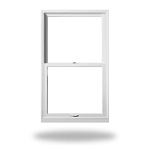 |  | 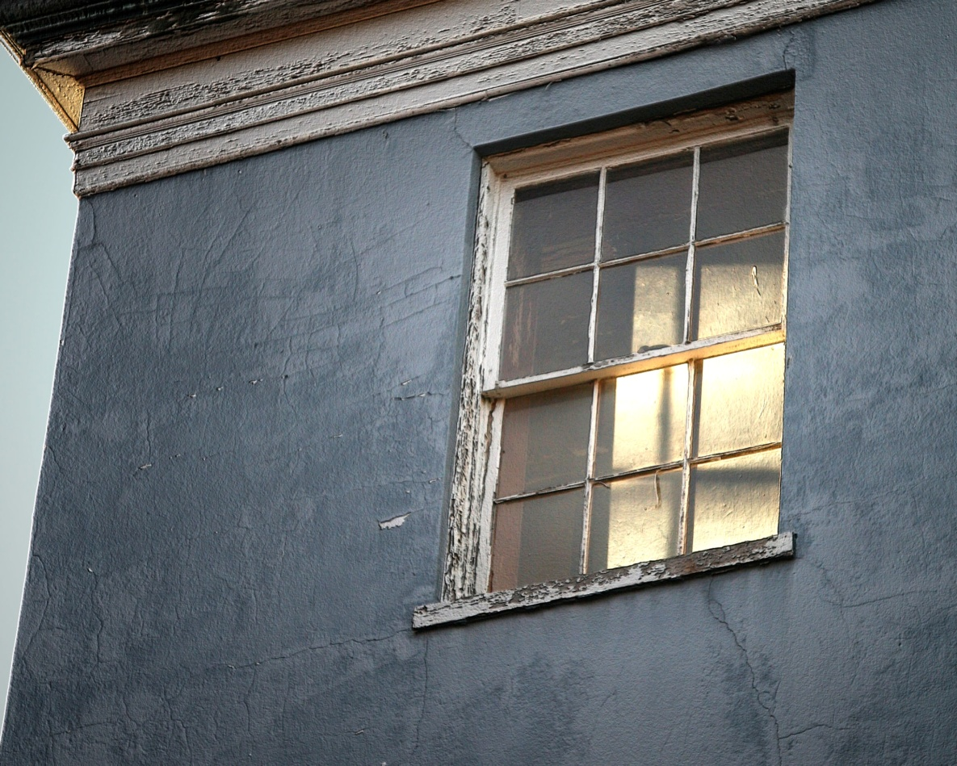
HUNG

SAMPLE PHOTOGRAPH & LABEL

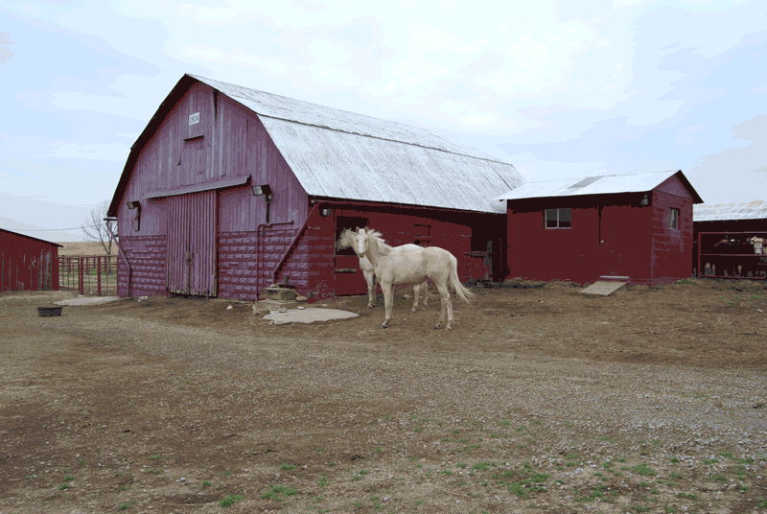
(Label on back of photograph)
Moore Ranch
6 miles west of Nowata on NXXXX Road
Nowata vicinity, Nowata County, Oklahoma
Lynda B. Schwan
March 20, 2009
Barn and Milk House
South and east elevations

Items on Label (label may be handwritten as long as it can be read)
Name of Property
Address/Location of Property
City/vicinity, County, State
Photographer
Date of Photograph
Building or structure being photographed
Direction from which the photograph is being taken

